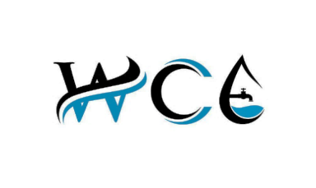



**WATSYS Consulting Engineers Private Limited**





**Our Organisation**

|  |  |  |
| --- | --- | --- |
| S.No. | Description | Details |
| 1 | Name of the Organisation | Watsys Consulting Engineers Private Limited |
| 2 | Year of Incorporation | 2018 |
| 3 | CIN | U74999KA2018PTC119278 |
| 4 | GST No. | 29AACCW3301M1Z7 |
| 5 | PAN No. | AACCW3301M |
| 6 | Company Email | info@watsysconsulting.com |
| 7 | Company Website | www.watsysconsulting.com |
| 8 | Company Landline No. |  |
| 9 | Contact Person | Shrivatsa Thilakprasad, Director |
| 10 | Contact No. | +91-9164 00 4600 |
| 11 | Email | shrivatsa.shrivatsa@gmail.com |
| 12 | Bangalore Office | 1232, 15th Main Road, BTM 2nd Stage, Bangalore, Karnataka, India - 560076 |
| 13 | Registered Office | #8, 3rd Cross, Garudachar Layout, Vijayanagar 3rd Stage, Mysuru, Karnataka, India - 570017 |

**WATSYS Consulting Engineers Private Limited** was incorporated in 2018 under the Companies Act, 2013. We are a specialised engineering and consulting service provider focused on Water Supply Systems, Under Ground Drainage (UGD) Systems, and Non-Revenue Water/ Un-Accounted for Water (NRW/UFW) Reduction. With extensive experience in urban and rural infrastructure development, we deliver reliable, sustainable, and technically strong solutions for government and private clients. With 105+ successfully completed projects across Karnataka state, we bring proven expertise in design, planning, hydraulic modelling, project documentation, and implementation support.

We possess proven expertise in Underground Drainage (UGD) systems, covering feasibility studies, detailed engineering, network design, and asset evaluation. Our work integrates technical, operational, and financial considerations to ensure efficient wastewater collection and conveyance systems that are reliable, cost-effective, and aligned with applicable standards and best practices.

In addition, we undertake comprehensive customer surveys and field investigations, generating accurate consumer-level datasets essential for planning, design billing, NRW reduction, and service optimization. Our capabilities also include DGPS based road and topographical surveys, providing precise ground-level data to support infrastructure design, alignment planning, and utility mapping. By combining robust field data with strong analytical expertise, we deliver practical, data-driven solutions that support informed decision-making and successful project outcomes.



**Our Core Services**

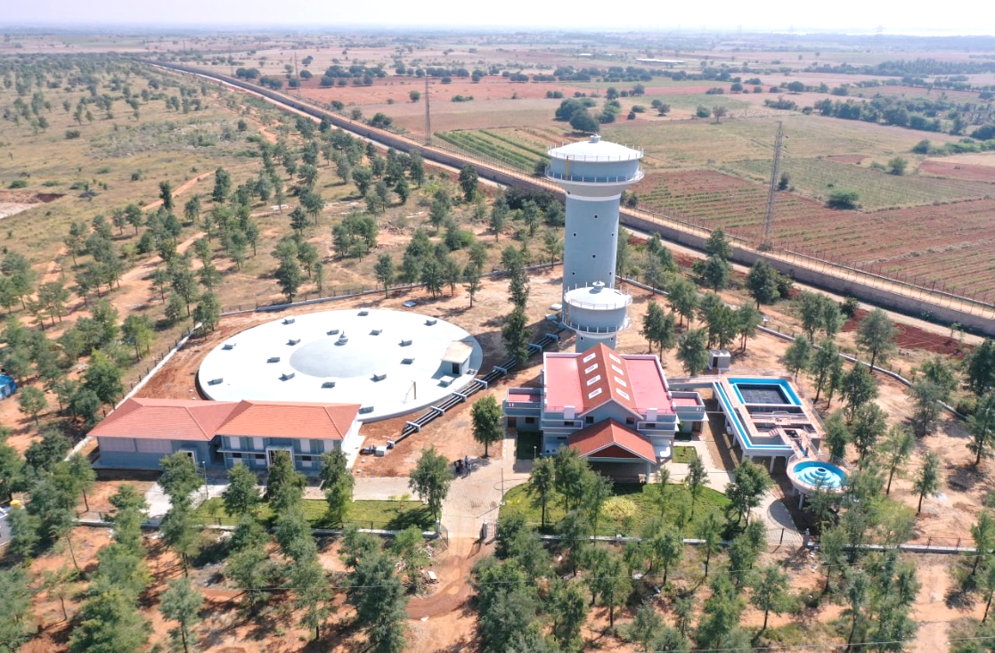**Water Supply Services**

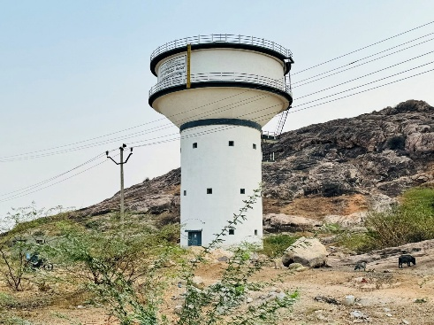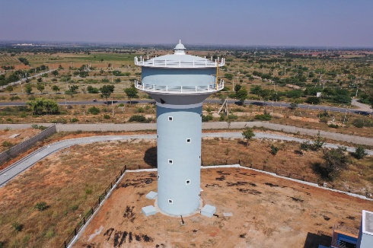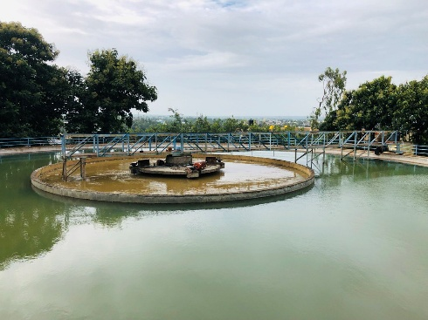

An assessment of the existing water supply system is undertaken to comprehensively evaluate the current infrastructure, operational performance, and service levels. The assessment covers sources of supply, treatment facilities, transmission and distribution networks, pumping and storage infrastructure, and consumer connections. Key aspects such as system capacity, continuity of supply, pressure adequacy, water quality, and non-revenue water is examined through field inspections, data review, and hydraulic analysis. The condition and age of assets, operational practices, and energy consumption are also reviewed to identify deficiencies, bottlenecks, and inefficiencies. The findings of the study assists in establishment of a reliable baseline for identifying system gaps and form the basis for developing technically sound and sustainable service improvement measures.

**Water Network Design & Modeling**

* Distribution network design using WaterGEMS
* DMA formation and hydraulic modelling
* Pumping Station Design, OHT/GLSR design, pipeline sizing and hydraulics, economisation of designs through pressure zoning

**Feasibility Studies & Project Planning**

* Existing system assessment
* Demand forecasting
* Technical and financial viability studies
* Service Level Bottlenecks in Existing system.



**Continuous (24x7) Water Supply System Planning**

Our consultancy provides comprehensive planning and design services for continuous (24x7) water supply systems, focusing on reliable, equitable, and sustainable service delivery. We undertake detailed demand assessment, hydraulic modelling, pressure zoning, and network optimisation to ensure uninterrupted supply at adequate pressure across all service areas. Our approach integrates NRW/UFW reduction, DMA formation, smart metering, and pressure management, enabling utilities to improve service levels, water efficiency, and revenue sustainability while ensuring long-term operational stability.

* Transition of intermittent systems to continuous supply.
* Development of working hydraulic models based on system inventory and analysis of gaps between existing system and simulations of scenarios.
* Pressure management and network zoning
* Smart metering, SCADA integration and analysis of current level of NRW/UFW.
* Sustainable planning aligned with NRW/UFW reduction metrics

**Intermittent Water Supply System Services**

We offer specialised consultancy services for the design and improvement of intermittent water supply systems, addressing operational constraints and equitable distribution challenges. Our services include system assessment, supply scheduling analysis, storage and pumping optimisation, and network strengthening to minimise pressure fluctuations and distribution inequities. Where required, we develop phased improvement and transition strategies to enable a gradual and technically sound conversion from intermittent to continuous water supply systems.

* Network assessment for scheduled/intermittent supply
* Optimization of distribution cycles
* Design improvements for equitable supply.
* Service Improvement Plan (SIP) for shifting from intermittent to Continuous Pressurised System (CPS) through systematic improvement of service regime.



**UFW/NRW Reduction Services**

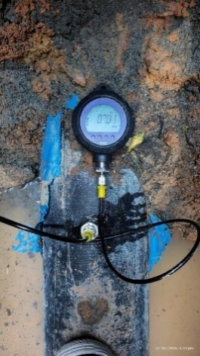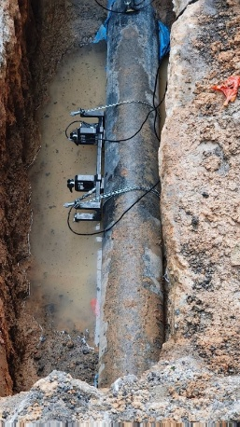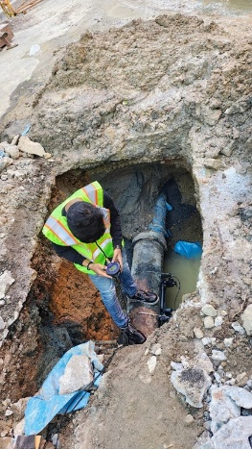

Non-Revenue Water (NRW), also referred to as Unaccounted-for Water (UFW), is a critical parameter in water supply management that represents the gap between the total water produced and the volume of water actually billed to consumers. High NRW/UFW levels indicate significant water losses due to leakages, illegal connections, meter inaccuracies, or operational inefficiencies.

Our company specializes in the assessment, reduction, and sustainable management of NRW/UFW through advanced network analytics, leak detection technologies, pressure management, and optimized distribution strategies. By implementing globally recognized best practices, we support utilities in enhancing system efficiency, improving financial performance, and ensuring reliable and equitable water delivery to all consumers.

* Baseline NRW/UFW assessment
* Water balance preparation
* Leak detection & pressure management
* DMA delineation and district metering area (DMA) strategy – Hydraulically Accounted Zoning
* Bulk Flow meter planning and house level service connection meter audits
* Commercial loss and physical loss reduction frameworks.
* Strategies and Term based plans for reduction of NRW/UFW





**UGD (Underground Drainage) Services**

1. **Sewer Network Design**

* Gravity sewer designs (lateral, main, and trunk sewers)
* Manhole design & spacing
* Alignment optimization

1. **2. Pumping & Lifting Station Design**

* Wet well/dry well design
* Rising main & pump capacity assessment
* Emergency handling design

1. **Wastewater Treatment System Support**

* Conceptual and preliminary design for STPs (SBR, MBBR, ASP, SBT, NEBR etc.)
* Hydraulic profile development
* Sludge and by-product management planning including planning of recirculation of treated sewage.

1. **Sewerage System Modelling**

* Surcharge and flooding simulation including flood discharge.
* Network capacity evaluation.

1. **DPR Preparation & Technical Documentation**

* Detailed Project Reports
* Preparation of pre-tender bidding documents.
* Tender documents
* BOQ, cost estimation & technical drawings
* GIS-based mapping for water and sewer systems
* Field surveys and asset documentation
* Flow and pressure monitoring analysis
* Preparation of detailed drawings of structural components.
* Preparation of Single Line Diagrams (SLDs) of electrical and Electro-mechanical Components.
* Energy efficiency assessment and Energy audit for pumping systems.
* Preparation of proposal and detailed component design for Automation and Monitoring including data acquisition (SCADA) for water supply and sanitation system.
* Project monitoring and implementation support
* As-built documentation

**UGD Services**

**Our Additional Technical Services**

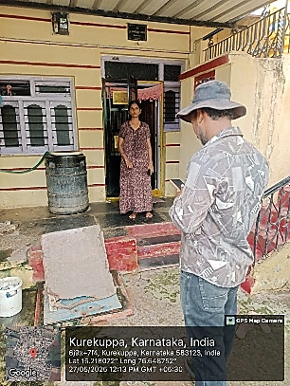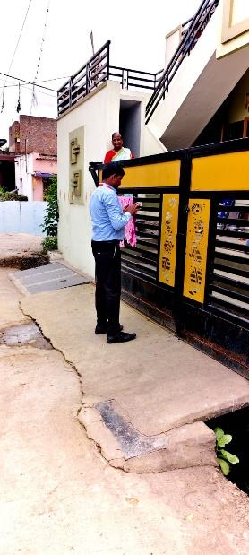

With extensive experience in executing House Service Connection Survey (Consumer Surveys) for water supply & UGD projects, our team conducts detailed house-to-house assessments to generate accurate and multiple urban and rural water supply assignments, we have successfully mapped lakhs of consumer connections, verified service lines, assessed meter conditions, recorded consumption patterns, and captured supply timings and service feedback. Each consumer is geo-tagged and integrated into a GIS-based network map, enabling utilities to clearly identify unauthorized connections, low-pressure areas, leakage-prone zones, and billing gaps. Our proven methodology and technology ensures high-quality datasets that support hydraulic modelling, NRW/UFW reduction strategies, and realistic demand estimation. This depth of experience allows us to deliver reliable, transparent, and customer-focused insights that strengthen the overall planning and execution of water supply improvement projects.

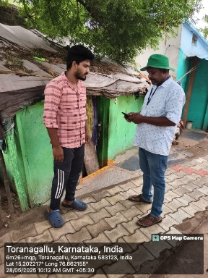

**Customer Survey**

The Customer Survey forms a critical component of both water supply and UGD projects. With extensive experience in conducting customer surveys, we generate accurate field-level data essential for planning, design, and NRW reduction in water supply systems, as well as for and capacity planning in UGD schemes. By developing an authentic and comprehensive consumer-level dataset, our surveys support demand assessment, hydraulic modelling, and the implementation of transparent, efficient, and customer-oriented water supply and UGD systems.

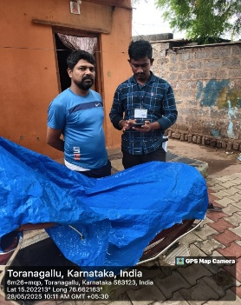

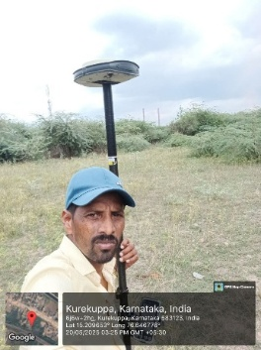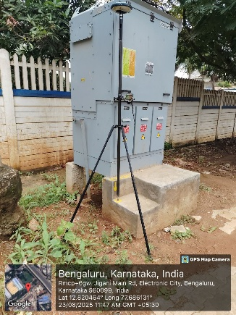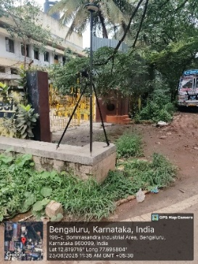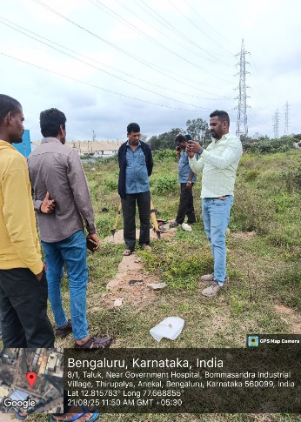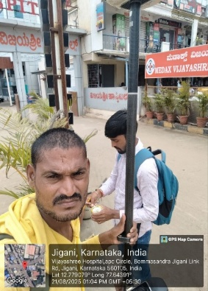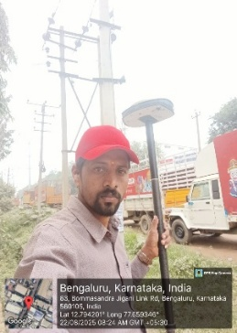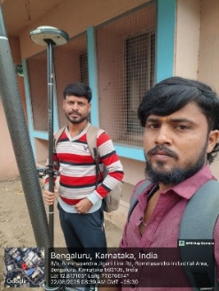





Our team brings strong technical expertise and extensive field experience in conducting Road Surveys for water supply infrastructure projects. We carry out precise measurements of road widths, centreline profiles, pavement layers, gradients, and existing utility crossings using advanced surveying instruments. The collected data is integrated into GIS-based corridor maps to identify alignment constraints, optimize trench locations, and plan safe crossings with telecom, electrical, drainage, and other underground utilities. This survey output supports accurate pipeline routing, excavation planning, and reinstatement design in compliance with road authority standards. With a proven record across diverse urban and rural environments, we ensure that every water supply project is supported by reliable, field-verified road data, facilitating smooth execution and minimizing public disruption.

**Topographical Survey**

**Our Team**

The Company is supported by a highly qualified and multidisciplinary team of professionals with extensive experience in water supply and wastewater infrastructure projects. The team comprises senior water supply engineers, hydraulic and network design specialists, UGD and wastewater experts, GIS and survey professionals, project planners, and financial and data analysts. With collective exposure to more than 100 projects across urban and rural settings, the team has proven expertise in feasibility studies, DPR preparation, hydraulic modelling, NRW reduction, continuous (24x7) water supply systems, sewerage and UGD planning, and implementation support. The team operates with a strong emphasis on international best practices, quality assurance, regulatory compliance, and client-focused delivery, ensuring technically robust, sustainable, and operation-friendly solutions across the entire project lifecycle.

**Director**

Mr. Shrivatsa, Director, is a highly accomplished water sector professional with primary expertise in the planning, design, and implementation of water supply systems, supported by complementary experience in Underground Drainage (UGD) and wastewater infrastructure. With leadership involvement in over 100 water supply and allied infrastructure projects across diverse urban and rural contexts, he has consistently delivered technically sound, resilient, and sustainable solutions aligned with international best practices. His core competencies include source development, transmission and distribution network design, hydraulic modelling, demand assessment, NRW reduction, and the transition from intermittent to continuous (24x7) water supply systems & preparation of strategies for service improvement and system operation. Known for his measured, collaborative, and client-centric leadership style, Mr. Shrivatsa provides strategic direction and technical oversight throughout the project lifecycle—from feasibility and detailed engineering to implementation support—ensuring quality, compliance, and long-term operational efficiency.



**Electro-Mechanical Expert**  
Mr. S. Raju is a highly experienced Electro-Mechanical Expert with over 15+ years of professional experience in the planning, design review, installation, testing, and commissioning of electro-mechanical systems for water supply and wastewater infrastructure projects. He possesses strong expertise in pumping systems, electrical panels, instrumentation, SCADA integration, and energy-efficient operations across both urban and rural schemes. His role includes ensuring system reliability, constructability, safety compliance, and operational efficiency while optimizing lifecycle costs. With extensive field exposure and proven coordination with civil, hydraulic, and O&M teams, Mr. Raju consistently contributes to the successful delivery of sustainable, performance-driven infrastructure solutions aligned with national and international standards.

**Structural Expert**  
Mr. Pawan M. Walvekar is a seasoned Structural Expert with over 10+ years of rigorous professional experience in the planning, analysis, design review, and execution support of diverse infrastructure projects, including Industrial Buildings, Water Treatment Plants (WTP), Sewage Treatment Plants (STP), Effluent Treatment Plants (ETP), and various residential, commercial, and infrastructure works. With successful involvement in more than 600+ projects, he brings strong expertise in RCC and steel structural systems, foundation design, constructability review, and multidisciplinary coordination. His extensive site exposure, combined with sound engineering judgment, ensures safe, economical, and code-compliant structural solutions. Mr. Walvekar plays a key role in delivering durable and sustainable designs while supporting timely project implementation and quality assurance across all stages of development.

**Financial Analyst**   
Mr. A. K. Basha is an accomplished Financial Analyst with over 15+ years of specialized experience in financial planning, investment analysis, and revenue assessment for water supply and wastewater infrastructure projects. He brings strong expertise in project financial modeling, CAPEX–OPEX analysis, tariff structuring, billing performance evaluation, and consumer consumption analytics. His core competencies include preparation of DCF-based models, affordability and willingness-to-pay assessments, revenue forecasting, and cost recovery frameworks that support informed decision-making. With extensive exposure to both urban and rural water projects, Mr. Basha plays a critical role in developing financially viable schemes, optimizing tariff strategies, improving billing efficiency, and strengthening utility financial performance. His data-driven approach and practical sector understanding consistently contribute to the preparation of bankable, implementation-ready projects aligned with government and funding agency requirements.

**Survey Expert (House-to-House Consumer Surveyor)**  
Mr. Pratap is an experienced Survey Expert with over 10+ years of dedicated professional experience in conducting large-scale house-to-house consumer surveys for water supply and urban infrastructure projects, with successful coverage of lakhs of customers across multiple project locations. He specializes in door-to-door data collection, consumer enumeration, service connectivity assessment, meter status verification, billing baseline surveys, and consumption profiling. Mr. Pratap brings strong field management capabilities, overseeing survey teams, ensuring data accuracy and validation, and maintaining strict adherence to project protocols and timelines. His extensive ground-level exposure enables reliable capture of customer demographics, usage patterns, and service gaps, providing a robust foundation for billing improvement, tariff studies, NRW assessment, and project planning. Known for operational efficiency, attention to detail, and effective stakeholder coordination, he plays a critical role in delivering authentic, high-quality consumer datasets that support informed decision-making and sustainable utility reforms.

**GIS Expert**  
Mr. Rajendra Gowda is a highly accomplished Roads and Topographical Survey Expert with over three decades of progressive field experience across highways, canals, transmission corridors, industrial layouts, and large-scale urban developments. He began his career in 1986, gaining early exposure to road construction supervision, alignment control, and minor bridge and culvert works. He subsequently served as Site Engineer on major canal packages, handling precision surveying using advanced instruments, hydraulic structure setting-out, concrete quality checks, bar bending schedules, and soil and material testing. His experience further extends to high-voltage transmission line projects, where he managed route alignment, longitudinal profiling, tower scheduling, and substation setting-out. As a Survey Engineer and Senior Survey Engineer, he led extensive topographical surveys covering thousands of acres for urban extensions, industrial estates, and manufacturing facilities, delivering contours, L-sections, and cross-sections using Total Station and CAD-based workflows. Mr. Gowda’s core strengths include large-area topographical mapping, road alignment surveys, industrial layout surveys, and infrastructure support surveys, backed by strong technical proficiency, deep field experience, and a reputation for accuracy, reliability, and timely delivery.

**Our Experience**

| **Sl.No** | **Project Name** | **Location** | **Client** | **Status** |
| --- | --- | --- | --- | --- |
| **1** | Providing 24x7 pressurized continuous water supply scheme to Ballari City under KMERC | Ballari | Sree Subha Sales Engineers & Contractors | Ongoing |
| **2** | Providing 24x7 pressurized continuous water supply scheme to Kurekuppa and Toranagallu under KMERC | Kurekuppa & Toranagallu | KMREC | Ongoing |
| **3** | Providing 24x7 pressurized continuous water supply scheme to Sandur under KMERC | Sandur | KMREC | Ongoing |
| **4** | Consultancy services for Remodeling of Water supply systems and reduction in UFW under Ulsoor Service Station area limits of BWSSB, Bangalore. | Bangalore | Indian Hume Pipe Co. Ltd | Ongoing |
| **5** | Consultancy services for Remodeling of Water supply systems and reduction in UFW under Domlur and Machalibetta Service Station area limits of BWSSB, Bangalore. | Bangalore | Maloo Constructions | Ongoing |
| **6** | Consultancy services for Remodeling of Water supply systems and reduction in UFW under CLR & Johnson Market Service Station area limits of BWSSB, Bangalore. | Bangalore | Indian Hume Pipe Co. Ltd | Ongoing |
| **7** | Consultancy services for Remodeling of Water supply systems and reduction in UFW under Jayamahal & Ramaswamy Palya Service Station area limits of BWSSB, Bangalore. | Bangalore | Maloo Constructions | Ongoing |
| **8** | Improvements of Water Supply System to Bangarpet & Malur Towns Under Amrut 2.0 Including Operation & Maintenance for A Period of 5 Years (Including 1 Year DLP)Through Design, Build, Operation and Transfer (DBOT) Mode (No Variation) | Malur & Bangarpet | KVR Construction Heights Pvt Ltd | Completed |
| **9** | Providing Water Supply Scheme to Sidlaghatta City and 13 Enroute Villages with Ramasamudra Tank as Source Under Amrut 2.0 (Tranche-3) Including Operation & Maintance for A Period of 5 Years (Including 1 Year DLP) Through Design, Build, Operation and Transfer (DBOT) Mode (No Variation)” | Sidlaghatta | Tripura Infra | Ongoing |
| **10** | Providing 24x7 pressurized continuous water supply scheme to Kuditini under KMERC | Kuditini | KMREC | Ongoing |
| **11** | Improvements of Water Supply System to Moodabidri Town Under Amurt 2.0 Including Operation & Maintenance for A Period of 5 Years Through Design, Build, Operation and Transfer (DBOT) Mode | Moodabidre | Sujala Structures & Sree Subha Sales - JV | Completed |
| **12** | Remodelling of Water Supply Distribution System to Tarikere, Kadur, Birur & Mudigere Towns of Chikkmagaluru District Under Amrut 2.0 Including O&M for 5 Years Through Design, Build, Operation and Transfer (DBOT) Mode | Mudigere | KVR Construction Heights Pvt Ltd | Completed |
| **13** | Providing Water Supply Distribution System to Nagamangala Town Including O & M for A Period of 5 Years Under Amrut 2.0 Tranche-2 Through Design, Build, Operate and Transfer. | Nagamangala | M/s. M N Ramesh Engineers and Contractor,  Tumakuru | Completed |
| **14** | Providing Water Supply Distribution System to Periyapatna Town From River Cauvery Near Dindagadu Village As Common Source to Kushalnagar and Periyapatna Towns Under Amrut 2.0 Including O&M for A Period of 5 Years Through DBOT Mode. | Periyapatna | Sudhanva Engineers And Builders  Bangalore | Completed |
| **15** | Improvements of Water Supply System to Sira City With Hemavathi Canal As Source Through Design, Build, Operation and Transfer (DBOT) Mode | Sira | M/s Giddegowda Contractors  Bangalore | Completed |
| **16** | Improvements to Water Supply System of Sringeri Town With Tunga River As Source Including Operation and Maintenance for A Period of 5 Years Under Amrut 2.0 Through Design, Build, Operate and Transfer (DBOT) Mode | Sringeri | NIthesh Kumar Engineers & Contractors | Completed |
| **17** | Providing Water Supply Distribution System to Kushalnagar Town From River Cauvery Near Dindagadu Village As Common Source to Kushalnagar and Periyapatna Towns Under Amrut 2.0 Including O&M for A Period of 5 Years Through DBOT Mode | Kushalnagar | Sudhanva Engineers And Builders  Bangalore | Completed |
| **18** | Providing Water Supply System to Rammanahalli TP by Pumping Water From Existing WTP At Rammanahalli With River Cauvery As Source Under Amrut 2.0 | Rammanahalli | M/s. M N Ramesh Engineers and Contractor,  Tumakuru | Completed |
| **19** | Improvements of Water Supply System to Sargur Town Under Amurt 2.0 Including Operation & Maintenance for A Period of 5 Years Through Design, Build, Operation and Transfer (DBOT) Mode | Sargur | Sujala Structures & Sree Subha Sales - JV | Completed |
| **20** | Improvements of Water Supply Scheme to Somwarpet, Virajpete Town of Kodagu District, Hunsuru City of Mysuru District, Alur town and Sakaleshpura Town Under Amrut 2.0 Through Design, Build, Operate and Transfer (DBOT) Mode | Alur | Sudhanva Engineers And Builders  Bangalore | Completed |
| **21** | Providing Water Supply Distribution System to Bashettihalli Town With O&M for 5 Years Under Amrut 2.0 Through DBOT | Bashettihalli | KUWS&DB | Completed |
| **22** | Providing Water Supply Distribution System to Chikka Banavara Town With O&M for 5 Years Under Amrut 2.0 Through DBOT | Chikka Banavara | KUWS&DB | Completed |
| **23** | Improvements of Water Supply Scheme to Honnali Town Under Amrut - 2.0 | Honnali | P. Sudheer Naidu  Engineers & Contractors | Completed |
| **24** | Water Supply Scheme to Hootagalli CMC | Hootgalli | Sree Subha Sales Engineers & Contractors | Completed |
| **25** | Providing Water Supply Scheme to Hosadurga Town Under Amrut- 2.0 | Hosadurga | KUWS&DB | Completed |
| **26** | Providing Pressurized Water Supply Distribution System to Hungund Town Including Operation & Maintenance For A period of 5 Years (Including 1 Year DLP) Under Amrut 2.0 Through Design, Build Operation and Transfer (DBOT) Mode | Hungund | M/s. M N Ramesh Engineers and Contractor,  Tumakuru | Completed |
| **27** | Improvements of Water Supply Scheme to Somwarpet, Virajpet Town of Kodagu District, Hunsuru City of Mysuru District, Alur town and Sakaleshpura Town Under Amrut 2.0 Through Design, Build, Operate and Transfer (DBOT) Mode | Hunsur | Sudhanva Engineers And Builders  Bangalore | Completed |
| **28** | Providing Water Supply Scheme to Jewargi and Aurad Towns Under Amrut 2.0 Including Operation & Maintenance for A Period of 5 Years (Including 1 Year DLP) Through Design, Build Operation and Transfer (DBOT) Mode | Jewargi | M/s. M N Ramesh Engineers and Contractor,  Tumakuru | Completed |
| **29** | Providing Water Supply Scheme to Jigani Town Under Amrut- 2.0 | Jigani | KUWS&DB | Completed |
| **30** | Providing Water Supply Scheme to Kadakola TP with Kabini River as Source Under Amrut 2.0” Including Operation & Maintenance for A Period of 5 Years Through Design, Build, Operation and Transfer (DBOT) Mode | Kodakola | M/s Giddegowda Contractors  Bangalore | Completed |
| **31** | Remodelling of Water Supply Distribution System to Tarikere, Kadur, Birur & Mudigere Towns of Chikkmagaluru District Under Amrut 2.0 Including O&M for 5 Years Through Design, Build, Operation and Transfer (DBOT) Mode | Kadur | KVR Construction Heights Pvt Ltd | Completed |
| **32** | Remodelling of Water Supply Distribution System to Tarikere, Kadur, Birur & Mudigere Towns of Chikkmagaluru District Under Amrut 2.0 Including O&M for 5 Years Through Design, Build, Operation and Transfer (DBOT) Mode | Birur | KVR Construction Heights Pvt Ltd | Completed |
| **33** | Remodelling of Water Supply Distribution System to Tarikere, Kadur, Birur & Mudigere Towns of Chikkmagaluru District Under Amrut 2.0 Including O&M for 5 Years Through Design, Build, Operation and Transfer (DBOT) Mode | Tarikere | KVR Construction Heights Pvt Ltd | Completed |
| **34** | Improvements of Water Supply Scheme to Kalaghatagi Town” Including Operation & Maintenance for A Period of 5 Years (Including 1 Year DLP) Under Amrut 2.0 Through Design, Build Operation and Transfer (DBOT) Mode | Kalaghatagi | M/s. M N Ramesh Engineers and Contractor,  Tumakuru | Completed |
| **35** | Providing Water Supply Distribution System to Kamatagi Town Including Operation & Maintenance for A Period of 5 Years (Including 1 Year DLP) Under Amrut 2.0 Through Design, Build Operation and Transfer (DBOT) Mode | Kamatagi | M/s. M N Ramesh Engineers and Contractor,  Tumakuru | Completed |
| **36** | Improvements of Water Supply System to Karkala Town with Ennehole River as Source Including O&M for A Period of 5 Years (Including 1 Year DLP) Through DBOT Mode | Karkala | Sree Subha Sales Engineers & Contractors | Completed |
| **37** | Providing Water Supply Scheme to Kaup Town & Enroute Villages With Udyavara River as Source | Kaup | Sujala Structures Engineers & Contractors | Completed |
| **38** | Providing Water Supply Scheme to Kembhavi Town in Shorapur Taluka, Yadgir District with Narayanpur Dam in Jaladhare Scheme Water as Source Under Amruth 2.0 Including O&M for A Period of 5 Years (Including 1 Year Defects Liability Period) Through Design, Build, Operate and Transfer (DOBT) Mode | Kembhavi | Sree Subha Sales  Engineers & Contractors | Completed |
| **39** | Combined Water Supply Scheme to Koppal City and Bhagyanagar Town Through Design, Build, Operation and Transfer (DBOT) Mode | Koppal City and Bhagyanagar | Chidu Infratech Pvt Ltd Gangavathi | Completed |
| **40** | Providing Combined Water Supply Scheme to Kuknuru, Yelburga Towns, Enroute Government Engineering Collage and To Cluster Industry From Tungabhdra Dam as Source Under Amrut-2.0 Including O & M for A Period of 5 Years (Including 1 Year DLP) Through DBOT Mode | Kuknoor & Yelburga | Denta Water and Infra Solutions Limited Bangalore | Completed |
| **41** | Improvements to Water Supply Scheme to Kunigal Town with Hemavathi Canal and Kunigal Doddakere as Source Under Amrut2.0 Through DBOT Mode Including 5 Years O & M | Kunigal | M/s. M N Ramesh Engineers and Contractor,  Tumakuru | Completed |
| **42** | Providing Water Supply Scheme to Kurugodu Town Under DC Work with TMC Kurgodu | Kurugodu | KUWS&DB | Completed |
| **43** | Providing Water Supply Distribution System to Left Out Areas of Naragund Town Including Operation & Maintenance for A Period of 5 Years (Including 1 Year DLP) Through Design, Build, Operation and Transfer (DBOT) Mode | Naragund | Sree Subha Sales  Engineers & Contractors | Completed |
| **44** | Improvements of Water Supply Scheme to Somwarpet, Virajpete Town of Kodagu District, Hunsuru City of Mysuru District, Alur town and Sakaleshpura Town Under Amrut 2.0 Through Design, Build, Operate and Transfer (DBOT) Mode | Sakaleshpura | Sudhanva Engineers And Builders  Bangalore | Completed |
| **45** | Providing Water Supply Scheme Distribution to Shahapur City and Bheemarayangudi (NAC) Town Including 5 Years O&M Through DBOT Mode | Shahapur and Bheemarayangudi | M/s Shivakumar Patil, Engineers & Contractor Pvt Ltd in JV with ABP & SSSEC | Completed |
| **46** | Improvements of Water Supply Scheme to Somwarpet, Virajpete Town of Kodagu District, Hunsuru City of Mysuru District, Alur town and Sakaleshpura Town Under Amrut 2.0 Through Design, Build, Operate and Transfer (DBOT) Mode | Somwarpet | Sudhanva Engineers And Builders  Bangalore | Completed |
| **47** | Improvements of Water Supply Scheme to Somwarpet, Virajpete Town of Kodagu District, Hunsuru City of Mysuru District, Alur town and Sakaleshpura Town Under Amrut 2.0 Through Design, Build, Operate and Transfer (DBOT) Mode | Virajpete | Sudhanva Engineers And Builders  Bangalore | Completed |
| **48** | Providing Water Supply System to Srirampura TP with Kabini River as Source Under Amrut 2.0 Including Operation & Maintenance for A Period of 5 Years Through Design, Build, Operation and Transfer (DBOT) Mode | Srirampura | Sree Subha Sales  Engineers & Contractors | Completed |
| **49** | Improvements of Water Supply System to Sullia Town with Payaswini River as Source Under Amrut 2.0 Including Operation & Maintenance for A Period of 5 Years (Including 1 Year DLP) Through Design, Build, Operation and Transfer (DBOT) Mode | Sullia | Sree Subha Sales  Engineers & Contractors | Completed |
| **50** | Providing Water Supply Scheme to Jewargi and Aurad Towns Under Amrut 2.0 Including Operation & Maintenance for A Period of 5 Years (Including 1 Year DLP) Through Design, Build Operation and Transfer (DBOT) Mode | Aurad | M/s. M N Ramesh Engineers and Contractor,  Tumakuru | Completed |
| **51** | Improvement of Water Supply System to Arakalgudu Town Under Amrut 2.0 Including Operation & Maintenance for A Period of 5 Years (Including 1 Year Defects Liability Period) Through Design, Build and Transfer (DBT) Mode | Arakalgudu | KVR Construction Heights Pvt Ltd | Completed |
| **52** | Providing Water Supply Distribution System to K R Pete Town Including O & M of 5 Years Under Amrut 2.0 | K.R.Pete | M/s Giddegowda Contractors  Bangalore | Completed |
| **53** | Providing Water Supply Distribution System to Pandavapura Town Including O & M of 5 Years Under Amrut 2.0 | Pandavapura | M/s Giddegowda Contractors  Bangalore | Completed |
| **54** | Providing Water Supply System to Saundatti Town Including Operation & Maintenance for A Period of 3 Years (Including DLP) Through Design, Build, Operation and Transfer (DBOT) | Saundatti | Sree Subha Sales  Engineers & Contractors | Completed |
| **55** | Providing Water Supply Distribution Network to Ullala City-IInd Phase | Ullala | KUWS&DB | Completed |
| **56** | Improvements of Water Supply System to Kerur City with Hemavathi Canal as Source Through Design, Build, Operation and Transfer (DBOT) Mode | Kerur | Haricons Engineers and Contractors | Completed |
| **57** | Improvements of Water Supply Scheme to Bellur Town of Mandya District, Hanur & Yelandur Towns of Chamarajanagar District and K.R.Nagar & H.D.Kote Towns of Mysuru District Under Amrut 2.0, Including the Operation and Maintenance for A Period of 5 Years Through Design, Built, Operate and Transfer (DBOT) Mode | Bellur | M/s. M N Ramesh Engineers and Contractor,  Tumakuru | Completed |
| **58** | Improvements of Water Supply Scheme to Bellur Town of Mandya District, Hanur & Yelandur Towns of Chamarajanagar District and K.R.Nagar & H.D.Kote Towns of Mysuru District Under Amrut 2.0, Including the Operation and Maintenance for A Period of 5 Years Through Design, Built, Operate and Transfer (DBOT) Mode | Hanur | M/s. M N Ramesh Engineers and Contractor,  Tumakuru | Completed |
| **59** | Improvements of Water Supply Scheme to Bellur Town of Mandya District, Hanur & Yelandur Towns of Chamarajanagar District and K.R.Nagar & H.D.Kote Towns of Mysuru District Under Amrut 2.0, Including the Operation and Maintenance for A Period of 5 Years Through Design, Built, Operate and Transfer (DBOT) Mode | Yelandur | M/s. M N Ramesh Engineers and Contractor,  Tumakuru | Completed |
| **60** | Improvements of Water Supply Scheme to Bellur Town of Mandya District, Hanur & Yelandur Towns of Chamarajanagar District and K.R.Nagar & H.D.Kote Towns of Mysuru District Under Amrut 2.0, Including the Operation and Maintenance for A Period of 5 Years Through Design, Built, Operate and Transfer (DBOT) Mode | K.R.Nagar | M/s. M N Ramesh Engineers and Contractor,  Tumakuru | Completed |
| **61** | Improvements of Water Supply Scheme to Bellur Town of Mandya District, Hanur & Yelandur Towns of Chamarajanagar District and K.R.Nagar & H.D.Kote Towns of Mysuru District Under Amrut 2.0, Including the Operation and Maintenance for A Period of 5 Years Through Design, Built, Operate and Transfer (DBOT) Mode | H.D.Kote | M/s. M N Ramesh Engineers and Contractor,  Tumakuru | Completed |
| **62** | Improvements of Water Supply System to Madhugiri, Gubbi, Turuvekere & Koratagere in Tumakuru District Under Amrut 2.0 Including Operation & Maintenance for A Period of 5 Years (Including 1 Year DLP) Through Design, Build, Operation and Transfer (DBOT) Mode | Madhugiri | M/s. M N Ramesh Engineers and Contractor,  Tumakuru | Completed |
| **63** | Improvements of Water Supply System to Madhugiri, Gubbi, Turuvekere & Koratagere in Tumakuru District Under Amrut 2.0 Including Operation & Maintenance for A Period of 5 Years (Including 1 Year DLP) Through Design, Build, Operation and Transfer (DBOT) Mode | Gubbi | M/s. M N Ramesh Engineers and Contractor,  Tumakuru | Completed |
| **64** | Improvements of Water Supply System to Madhugiri, Gubbi, Turuvekere & Koratagere in Tumakuru District Under Amrut 2.0 Including Operation & Maintenance for A Period of 5 Years (Including 1 Year DLP) Through Design, Build, Operation and Transfer (DBOT) Mode | Turuvekere | M/s. M N Ramesh Engineers and Contractor,  Tumakuru | Completed |
| **65** | Improvements of Water Supply System to Madhugiri, Gubbi, Turuvekere & Koratagere in Tumakuru District Under Amrut 2.0 Including Operation & Maintenance for A Period of 5 Years (Including 1 Year DLP) Through Design, Build, Operation and Transfer (DBOT) Mode | Koratagere | M/s. M N Ramesh Engineers and Contractor,  Tumakuru | Completed |
| **66** | Providing Water Supply System to Chikkaballapur City, Chintamani City, Gowribidanur City & 8 Enroute Villages, Bagepalli & Gudibande Towns Under Amrut 2.0 Including Operation & Maintenance for A Period of 5 Years (Including 1 Year DLP) Through Design, Build, Operation and Transfer (DBOT) Mode. (No Variation) | Bagepalli | M/s. M N Ramesh Engineers and Contractor,  Tumakuru | Completed |
| **67** | Providing Water Supply System to Chikkaballapur City, Chintamani City, Gowribidanur City & 8 Enroute Villages, Bagepalli & Gudibande Towns Under Amrut 2.0 Including Operation & Maintenance for A Period of 5 Years (Including 1 Year DLP) Through Design, Build, Operation and Transfer (DBOT) Mode. (No Variation) | Gudibande | M/s. M N Ramesh Engineers and Contractor,  Tumakuru | Completed |
| **68** | Providing Water Supply System to Chikkaballapur City, Chintamani City, Gowribidanur City & 8 Enroute Villages, Bagepalli & Gudibande Towns Under Amrut 2.0 Including Operation & Maintenance for A Period of 5 Years (Including 1 Year DLP) Through Design, Build, Operation and Transfer (DBOT) Mode. (No Variation) | Chikkaballapur | M/s. M N Ramesh Engineers and Contractor,  Tumakuru | Completed |
| **69** | Providing Water Supply System to Chikkaballapur City, Chintamani City, Gowribidanur City & 8 Enroute Villages, Bagepalli & Gudibande Towns Under Amrut 2.0 Including Operation & Maintenance for A Period of 5 Years (Including 1 Year DLP) Through Design, Build, Operation and Transfer (DBOT) Mode. (No Variation) | Chintamani | M/s. M N Ramesh Engineers and Contractor,  Tumakuru | Completed |
| **70** | Providing Water Supply System to Chikkaballapur City, Chintamani City, Gowribidanur City & 8 Enroute Villages, Bagepalli & Gudibande Towns Under Amrut 2.0 Including Operation & Maintenance for A Period of 5 Years (Including 1 Year DLP) Through Design, Build, Operation and Transfer (DBOT) Mode. (No Variation) | Gowribidanur | M/s. M N Ramesh Engineers and Contractor,  Tumakuru | Completed |
| **71** | Providing HDPE Distribution Network for Balance Areas (17 Wards) of Hassan CMC and New Added Adjoining Villages | Hassan | KUWS&DB | Completed |
| **72** | Providing Water Supply System Manki Town” Under Amrut 2.0 Including Operation & Maintenance for A Period of 5 Years (Including 1 Year DLP) Through Design, Build, Operation and Transfer (DBOT) Mode | Manki | Sudhanva Engineers And Builders  Bangalore | Completed |
| **73** | Improvements of Water Supply System to Narasimharajapura Town, Including 5 YearsOperation and Maintianance Under DBOT Mode Under Amrut-2.0. | N.R Pura | NIthesh Kumar Engineers & Contractors | Completed |
| **74** | Improvements to Water Supply System of Chamarajanagara City Under Amrut 2.0 Including O & M for A Period of 5 Years Through DBOT Mode | Chamarajanagara | M/s. M N Ramesh Engineers and Contractor,  Tumakuru | Completed |
| **75** | Providing 3rd Stage Water Supply Scheme to Chamarajanagar City from Cauvery River as Source Near Malangi Village. | Chamarajanagara | M/s. M N Ramesh Engineers and Contractor,  Tumakuru | Completed |
| **76** | Improvement of Water Supply System to Srirangapatna Town with Cauvery River as Source Under Amrut 2.0 (Tranche - 3) Including Operation & Maintenance for A Period of 5 Years (Including 1 Year DLP) Through Design, Build, Operation and Transfer (DBOT) Mode | Srirangapatna | M/s. M N Ramesh Engineers and Contractor,  Tumakuru | Completed |
| **77** | Providing Water Supply Distribution System to Kushalnagar Town from River Cauvery Near Dindagadu Village as A Source to Kushalnagar Town | Kushalnagar | KUWS&DB | Ongoing |
| **78** | Providing Water Supply Scheme to Bogadi TP Under Amrut 2.0 Including O& M for A Period of 5 Years Through DBOT Mode | Bogadi | M/s Giddegowda Contractors  Bangalore | Completed |